**WIFI JAMMER USING IOT**

*A mini-project report submitted in partial fulfillment of the Academic requirements for the award of the Degree of*

**BACHELOR OF ENGINEERING**

**IN**

**INFORMATION TECHNOLOGY**

**By**

**KONDA REVAN (2451-19-737-178)**

**VEMURI YOGESH (2451-19-737-180)**

**NALLA SUSHMA (2451-19-737-313)**

***Under the guidance of***

**Ch . Srujana**

**Assistant Professor,Dept of IT**



**DEPARTMENT OF INFORMATION TECHNOLOGY**

**MATURI VENKATA SUBBA RAO (MVSR) ENGINEERING COLLEGE**

**(An Autonomous Institution)**

**(Affiliated to Osmania University, Hyderabad. Recognized by AICTE)**

**Nadergul, Saroornagar Mandal, Hyderabad-501510**

**2021-2022**

**MATURI VENKATA SUBBA RAO (MVSR)**

**ENGINEERING COLLEGE**

**(An Autonomous Institution)**

**(Affiliated to Osmania University, Hyderabad. Recognized by AICTE)**

**Nadergul, Saroornagar Mandal, Hyderabad-501510**



**DEPARTMENT OF INFORMATION TECHNOLOGY**

**CERTIFICATE**

This is to certify that the mini project work entitled “**WIFI JAMMER USING IOT**” is a bonafide work carried out by **K. Revan ( 2451-19-737-178 ), V. Yogesh**

**(2451-19-737-180), N. Sushma (2451-19-737-313)** in partial fulfillment of the requirements for the award of degree of **Bachelor of Engineering** in **Information Technology** from **Maturi Venkata Subba Rao (M.V.S.R.) Engineering College,** affiliated to OSMANIA UNIVERSITY, Hyderabad, during the Academic Year 2021-22. under our guidance and supervision.

The results embodied in this report have not been submitted to any other university or institute for the award of any degree or diploma.

Signature of Project Coordinator Signature of Guide

Signature of Head, ITD Signature of External Examiner

**DECLARATION**

This is to certify that the work reported in the present mini-project entitled “WiFi Jammer using IOT” is a record of bonafide work done by us in the Department of Information Technology, M.V.S.R. Engineering College, Osmania University. This report is based on the project work done entirely by us and not copied from any other source.

The results embodied in this project report have not been submitted to any other University or Institute for the award of any degree or diploma to the best of our knowledge and belief.

| **Roll Number** | **Student Name** | **Signature** |
| --- | --- | --- |
| 2451-19-737-178 | 1. REVAN |  |
| 2451-19-737-180 | V. YOGESH |  |
| 2451-19-737-313 | 1. SUSHMA |  |

**ACKNOWLEDGEMENT**

We with extreme jubilance and deepest gratitude, would like to thank our guide, **Ch. Srujana**, **Assistant Professor**, Department of Information Technology, Maturi Venkata Subba Rao (MVSR) Engineering College, for her constant encouragement to us to complete our work in time.

With immense pleasure, we record our deep sense of gratitude to our beloved Head of the department **Dr. K. Venu Gopala Rao** Dean-Academics & HOD, Department of Information Technology, Maturi Venkata Subba Rao Engineering College, for permitting and providing facilities to carry out this project.

We would like to extend our gratitude to **Dr.D.Shanthi**, Assoc. Prof. & **Project Coordinator**, **J.Sowjanya** and **D.Muninder Assistant Professo**r, **Section coordinators**, Department of Information Technology, Maturi Venkata Subba Rao Engineering College, for their valuable suggestions and timely help during the course of the project.

Finally, we express, from the bottom of our heart and deepest gratitude to the entire faculty, my parents and family for the support, dedication, comprehension and love.

**K. REVAN(2451-19-737-178)**

**V. YOGESH (2451-19-737-180)**

**N. SUSHMA (2451-19-737-313)**

**MVSR Engineering College**

**Department of Information Technology**

**COURSE NAME: MINI PROJECT I**

**COURSE CODE: PC 633 IT**

**VISION**

To impart technical education to produce competent and socially responsible engineers in the field

of Information Technology.

**MISSION**

M1. To make the teaching-learning process effective and stimulating.

M2. To provide adequate fundamental knowledge of sciences and Information Technology with positive attitude.

M3. To create an environment that enhances skills and technologies required for industry.

M4. To encourage creativity and innovation for solving real world problems.

M5. To cultivate professional ethics in students and inculcate a sense of responsibility towards society

**PROGRAM EDUCATIONAL OBJECTIVES (PEOs)**

The Bachelor’s program in Information Technology is aimed at preparing graduates who will:

I. Apply knowledge of mathematics and Information Technology to analyze, design and

implement solutions for real world problems in core or in multidisciplinary areas.

II. Communicate effectively, work in a team, practice professional ethics and apply knowledge

of computing technologies for societal development.

III. Engage in Professional development or postgraduate education to be a life-long learner.

**PROGRAM OUTCOMES (POs)**

1. Engineering knowledge: Apply the knowledge of mathematics, science,

engineering fundamentals, and an engineering specialization to the solution of complex engineering problems.

2. Problem analysis: Identity, formulate, review research literature, and analyze

complex engineering problems reaching substantiated conclusions using the first principles of mathematics, natural sciences, and engineering sciences.

3. Design/development of solutions: Design solutions for complex engineering problems

and design system components or processes that meet the specified needs with appropriate

consideration for the public health and safety, and the cultural, societal, and environmental

considerations.

4. Conduct investigations of complex problems: Use research-based knowledge and

research methods including design of experiments, analysis and interpretation of data, and synthesis of the information to provide valid conclusions.

5. Modern tool usage: Create, select, and apply appropriate techniques, resources, and

modern engineering and IT tools including prediction and modelling to complex engineering activities with an understanding of the limitations.

6. The engineer and society: Apply reasoning informed by the contextual knowledge to

assess societal, health, safety, legal and cultural issues and the consequent responsibilities relevant to the professional engineering practice.

7. Environment and sustainability: Understand the impact of the professional engineering

solutions in societal and environmental contexts, and demonstrate the knowledge of, and need for sustainable development.

8. Ethics: Apply ethical principles and commit to professional ethics and responsibilities and norms of the engineering practice.

9. Individual and team work: Function effectively as an individual, and as a member or leader in diverse teams, and in multidisciplinary settings.

10. Communication: Communicate effectively on complex engineering activities with the

engineering community and with society at large, such as, being able to comprehend and write effective reports and design documentation, make effective presentations, and give and receive clear instructions.

11. Project management and finance: Demonstrate knowledge and understanding of

the engineering and management principles and apply these to one’s own work, as a member and leader in a team, to manage projects and in multidisciplinary environments.

12. Life-long learning: Recognize the need for, and have the preparation and ability to engage in independent and life-long learning in the broadest context of technological change.

**PROGRAM SPECIFIC OUTCOMES (PSOS):**

(1) Hardware design: An ability to analyze, design, simulate and implement computer hardware/software and use basic analog/digital circuits, VLSI design for various computing and communication system applications.

(2) Software design: An ability to analyze a problem, design algorithm, identify and define the

computing requirements appropriate to its solution and implement the same.

**COURSE OBJECTIVES:**

1. To enhance practical & Professional skills.

2.To familiarize the tools and techniques of symmetric literature survey and documentation.

3. To expose students to industry practices and teamwork.

4. To encourage students to work with innovative and entrepreneurial ideas.

**COURSE OUTCOMES:**

On successful completion of this course students will be able to:

1. Define a problem of the recent advancements with applications towards society.

2. Outline requirements and perform requirement analysis for solving the problem.

3. Design and develop a software and/or hardware-based solution within the scope of project using contemporary technologies and tools.

4. Test and deploy the applications for use.

5. Develop the Project as a team and demonstrate the application, with effective written and oral communications.

**ABSTRACT**

We live in a scary time if we are someone who values privacy. We no longer know who is looking at what we search and who they are selling that information to. With the advent of cell phones and drones, it has become difficult to even go outside without the potential existing that we are being filmed or watched. This jammer is designed to be carried around in our pocket, it provides 10 meters of protection no matter where we are. This jammer is effective if we are working with sensitive data away from work or our home, like a hotel or some other more public space.

**LIST OF FIGURES**

| **FIGURE NO** | **NAME OF THE FIGURE** | **PAGE NO.** |
| --- | --- | --- |
| 3.1 | Block diagram | 14 |
| 3.1.1 | Power supply | 14 |
| 3.2 | Node MCU pinout diagram | 16 |
| 3.3 | Sequence Diagram | 17 |
| 4.1 | Arduino IDE installation | 18 |
| 4.1.1 | ESP8266 Package | 19 |
| 4.1.2 | Installing Board Package | 19 |
| 4.1.3 | Uploading Code | 20 |
| 5.1 | Connecting to SSID | 23 |
| 5.2 | Scanning Networks | 24 |
| 5.3 | Selecting Networks | 24 |
| 5.4 | Selecting Attack | 25 |
| 5.5 | Deauth Attack | 25 |
| 5.6 | Beacon Attack | 26 |
| 5.7 | Creating custom SSID | 26 |
| 5.8 | Enabling random SSIDs | 27 |

# TABLE OFCONTENTS

**CONTENTS PAGE NO.**

**TITLE 1**

**CERTIFICATE 2**

**DECLARATION 3**

**ACKNOWLEDGEMENT 4**

**VISION 5**

**MISSION 5**

**PROGRAM OUTCOMES 6**

**COURSEOBJECTIVES 7**

**COURSE OUTCOMES 7**

**ABSTRACT 8**

**LIST OF FIGURES 9**

**TABLE OF CONTENTS 10**

**CHAPTER 1: INTRODUCTION 11**

1.1 PROBLEM STATEMENT 11

1.2 OBJECTIVES 12

1.3 MOTIVATION 12

1.4 SCOPE 12

**CHAPTER 2: SYSTEM REQUIREMENT SPECIFICATION 13**

2.1 SOFTWARE REQUIREMENTS

2.2 HARDWARE REQUIREMENTS

**CHAPTER 3: SYSTEM DESIGN 14**

3.1 BLOCK DIAGRAM 14

3.1.1 BLOCK DIAGRAM DESCRIPTION 14

3.2 NODE MCU DEVELOPMENT BOARD 16

3.3 SEQUENCE DIAGRAM 17

**CHAPTER 4: IMPLEMENTATION 18**

4.1 ENVIRONMENTAL SETUP 18

4.2 MODULE DESCRIPTION 22

**CHAPTER 5: RESULTS 23**

**CHAPTER 6: CONCLUSION AND FUTURE ENHANCEMENTS 28**

**REFERENCES 29**

**APPENDIX 30**

**CHAPTER 1**

**INTRODUCTION**

Over the past few years, there have been quite a several choices in conventional technology and wireless technology to meet security needs for households or offices.Whether it is the wrong place or perhaps the wrong time, someone may feel that they do now want to have digital communication enabled. Wi-Fi jamming is not simply for convenience, there are tactical uses for it.

Since a great deal of sensitive data is stored digitally, it can be stolen undetected over a wifi network. Systems have disadvantages when access is stolen by people who do not have the authority to gain access and also daily activities sometimes force someone to have the house empty, such as during work or school hours. This makes the house or the organization vulnerable to data breach. By jamming wifi signals in the area, the owner of the data can make sure that no one is accessing it after hours.

**1.1 PROBLEM STATEMENT**

In general we use “IEEE 802.11 b/g/n” standards of WiFi communications. Management frames are transmitted in un-encrypted form in these standards which are used widely on most of the devices. So basically an attacker can easily sniff these frames. What attacker has to do is send copy of that frame with deauth request in it with spoofed address of AP station and Mac address of client is injected. And attacker only has to know mac address of client AP to send frame which is broadcast in open air every time.

**1.2 OBJECTIVES**

The objective of this project:

* To prevent unauthorized access.
* To allow only authorized person and ensure security.

**1.3 MOTIVATION**

The number of attacks are increasing day by day. Various security measures are being implemented in order to eradicate them. However,attacks continue to increase and there is always a need for a better security system. So,the motivation for this project is to decrease the attacks and enhance the safety and security of a person or an organization.

**1.4 SCOPE**

* The scope of this project is limited and can be used within organizations,buildings like schools,offices where only certain authorized users must access and can also be used at individual’s residence where only particular family members are allowed to access the jammer.
* The main aim or purpose of this project is to ensure secured means of network and data communication within the individual or organization and allow only authorized users to access the network and restrict unauthorized users from accessing the data thereby ensuring security and preventing unauthorized access.

**CHAPTER 2**

**SYSTEM REQUIREMENTS SPECIFICATIONS**

**2.1 HARDWARE REQUIREMENTS**

* Laptop / Desktop : Dual core processor (or above)
* Node Mcu : ESP 8266 (12E)
* Data Transfer Cable : Type A to Micro usb

**2.2 SOFTWARE REQUIREMENTS**

* Operating System : Windows 7/8/10
* IDE : Arduino

**CHAPTER 3**

**SYSTEM DESIGN**

**3.1 BLOCK DIAGRAM**

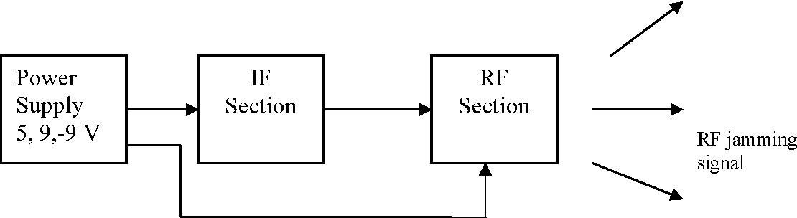

Fig-3.1 BLOCK DIAGRAM

**3.1.1 Block Diagram Description**

#### **Power supply**

The power supply is used to provide the power to the entire sections in the mobile jammer with the available voltages. The basic block diagram of [the power supply](https://www.elprocus.com/types-of-uninterruptible-power-supply-devices/)consists of the following parts.

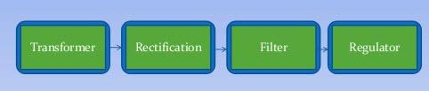

Fig-3.1.1 POWER SUPPLY

**Transformer:** The transformer is used to transform the 220V AC to the other voltage levels(step up and step down)

**Rectification:** The rectification is used to convert the AC voltage to the DC voltage and this process can be done in two methods which are **full wave & half wave rectification**

**Half wave Rectification:** During the [half wave rectification](https://www.elprocus.com/half-wave-rectifier-circuit-working-principle-and-characteristics-2/) the input signal should be positive cycle, hence the output voltage will be appearing

**Full wave Rectification:** In this type of rectifications the input signal should be in both i.e. in positive and negative cycles hence the output voltage will be appear.

**Filter:** In this the large capacitors are used to minimize the ripples in the output. The filter is used in the output of [full wave rectifier](https://www.elprocus.com/full-wave-rectifier-circuit-working-theory/) to eliminate the noise & fluctuations to provide the constant DC voltage

**Regulators:** The regulators are used to provide a preferred DC voltage.

#### **IF Section**

The IF section is just a triangular or saw tooth wave generator. With the help of desired range of frequencies the tuning section of the jammer brushes the VCO. To compensate the proper amount of VCO from the desired frequency to the maximum. The noise which is mixed with triangular waves is generated by the tuning signal. The IF section is divided into three main sections which are given below

* Noise generator
* Mixer
* Triangular wave generator

#### **RF Section**

The RF section is the heart of the mobile jammer because the output of the RF section is interacting with the mobile. There are three main sections in the RF section which are voltage controlled oscillator, power amplifier and antenna. The [voltage controlled oscillator](https://www.elprocus.com/voltage-controlled-oscillator-working-application/) is very important in the RF section and it is a device. The RF section generates the RF signal which is interacting with **the cell phones**. The VCO output frequency is directly proportion to the input voltage, hence we can manage the output frequency with the help of input voltage. If the input voltage is DC then the out has a specific range of frequency or we have the triangular wave form is the input then the output will be extended to the specific range of frequency.

**3.2 NODE MCU DEVELOPMENT BOARD**

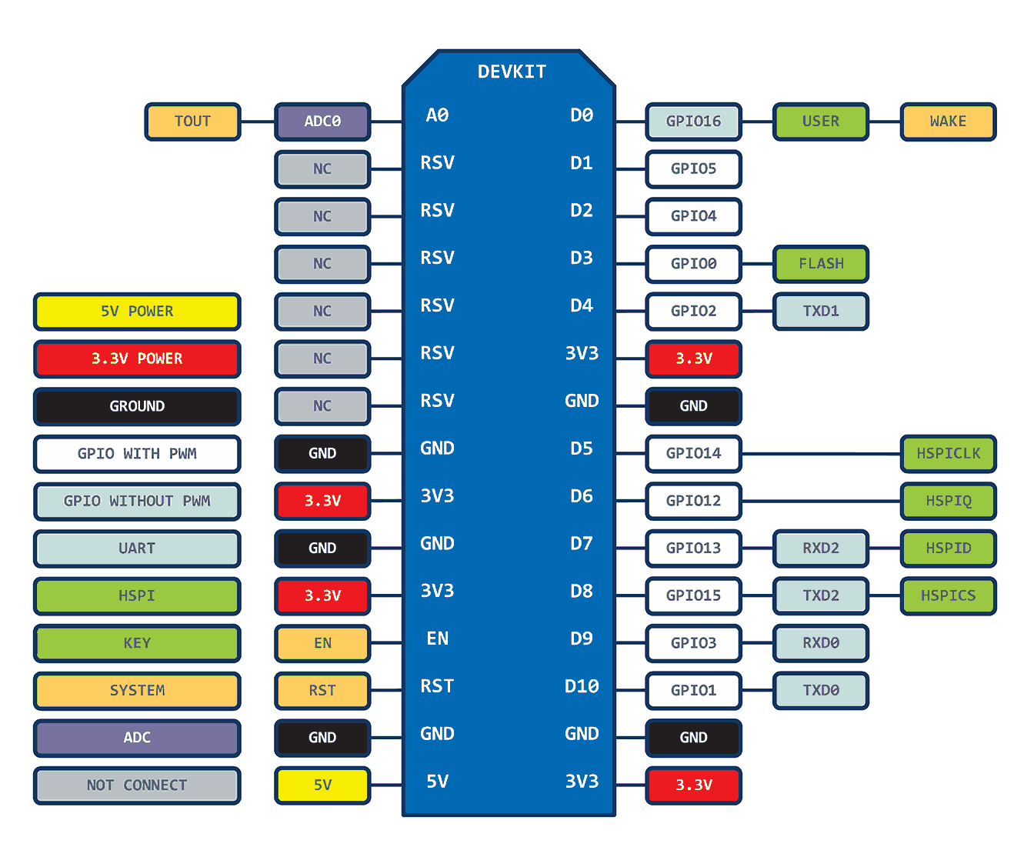 Fig-3.2 NODEMCU PINOUT DIAGRAM

For practical purposes, **ESP8266 NodeMCU** boards are present in identical pinouts. While working on the NodeMCU based projects we are interested in the following pins.

Power pins (3.3 V).

Ground pins (GND).

Analog pins (A0).

Digital pins (D0 – D8, SD2, SD3, RX, and TX – GPIO XX)

Most ESP8266 NodeMCU boards have one input voltage pin (Vin), three power pins (3.3v), four ground pins (GND), one analog pin (A0), and several digital pins (GPIO XX).

**3.3 Sequence Diagram**

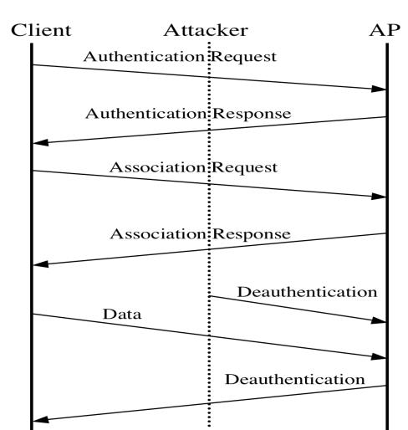

Fig-3.3 SEQUENCE DIAGRAM

Unlike most [radio jammers](https://en.wikipedia.org/wiki/Radio_jamming), deauthentication acts in a unique way. The [IEEE 802.11](https://en.wikipedia.org/wiki/IEEE_802.11) (Wi-Fi) protocol contains the provision for a [deauthentication frame](https://en.wikipedia.org/wiki/802.11#Deauthentication_frame). Sending the frame from the access point to a station is called a "sanctioned technique to inform a rogue station that they have been disconnected from the network".

An attacker can send a deauthentication frame at any time to a wireless access point, with a [spoofed](https://en.wikipedia.org/wiki/Spoofing_attack) address for the victim. The protocol does not require any encryption for this frame, even when the session was established with [Wired Equivalent Privacy](https://en.wikipedia.org/wiki/Wired_Equivalent_Privacy) (WEP) for [data privacy](https://en.wikipedia.org/wiki/Data_privacy), and the attacker only needs to know the victim's MAC address, which is available [in the clear](https://en.wikipedia.org/wiki/Plaintext) through wireless [network sniffing](https://en.wikipedia.org/wiki/Network_sniffers).

**CHAPTER 4**

**IMPLEMENTATION**

**4.1 ENVIRONMENTAL SETUP**

**Installing Arduino IDE**:

1. To download and install Arduino IDE visit the official website of Arduino IDE **https://www.arduino.cc/en/software** and choose your version.

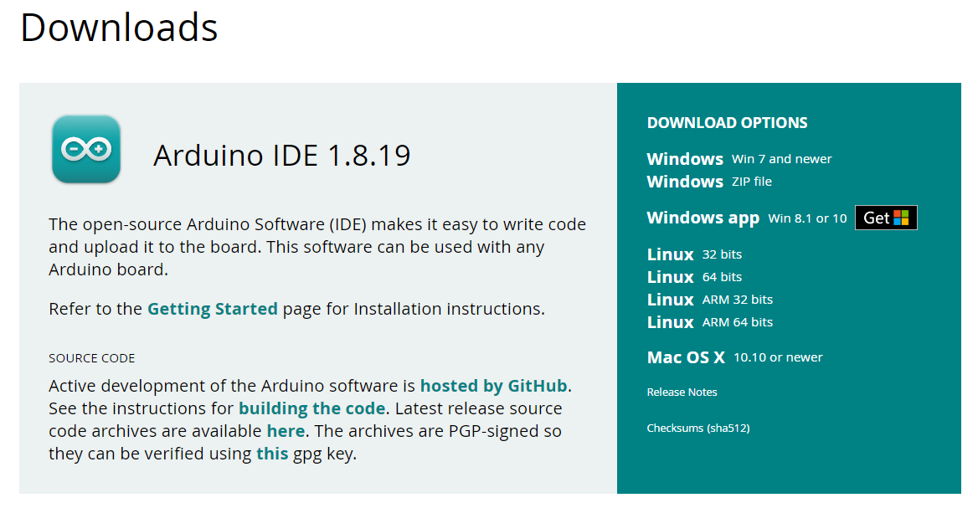 FIG-4.1 Arduino IDE INSTALLATION

1. Once the download is complete, run the exe to install Arduino IDE. Now click on Install Now.
2. You can see Arduino IDE installing at this point.
3. When it finishes, you can see a screen that says the Setup was successful. Now click on "Close".

**Installing ESP8266 Package** :

To install ESP8266 package nagivate to the following path go to *File -> Preferences* in Arduino IDE and add this link **http://arduino.esp8266.com/stable/package_esp8266com_index.json**  to the Additional Boards Manager URLs and Click on OK.

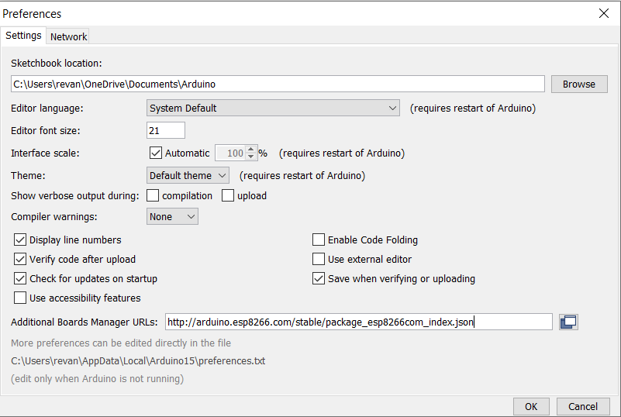

FIG-4.1.1 ESP 8266 Package

1. Close the Arduino IDE and Reopen it.
2. Click on *Tools -> Board -> Board Manager*. Search for ESP8266.

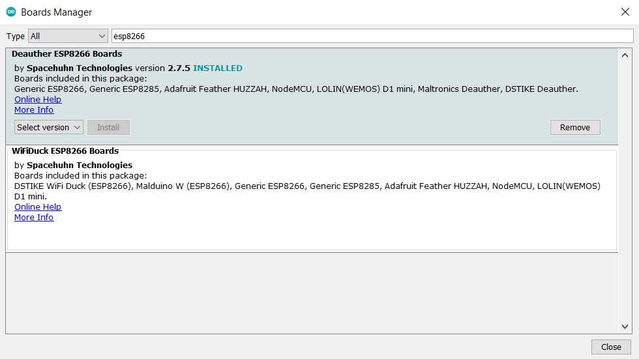

FIG-4.1.2 INSTALLING BOARD PACKAGE

1. Again go to *File -> Preferences* and click the folder path under *More preferences*.
2. Now, open the packages -> esp8266 -> hardware -> esp8266- > 2.0.0 -> tools -> sdk -> include and open the  *user_interface.h* file with the text editor.
3. Come to last line of the code and before *#endif*  and add these lines:

**typedef void (**freedom_outside_cb__t)(uint8 status);**

**int wifi_register_send_pkt_freedom_cb(freedom_outside_cb_t cb);**

**void wifi_unregister_send_pkt_freedom__cb(void);**

**int wifi_send_pkt_freedom(uint8 **buf, int len, bool sys_seq);**

Then save the file.

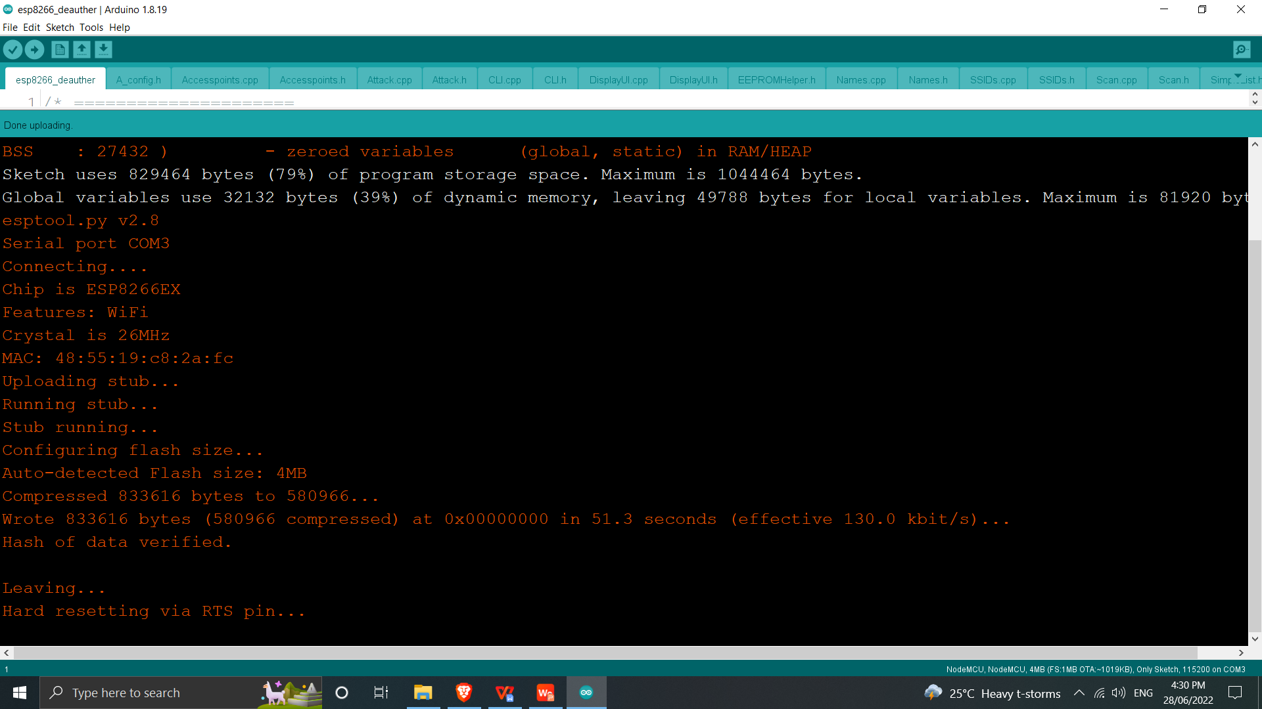FIG-4.1.3 UPLOADING CODE

1. Now, connect your laptop or smartphone with Access Point created by NodeMCU. Name of AP is “pwned” and password is “deauther” These are default name and password which you can see on serial monitor .
2. Open your browser and enter this address 192.168.4.1 .

**1. System**

* **1.1 Connect AP :** Connect the access point created by the Node MCU module.
* **1.2 Functional Usage :**
  + Open your browser and enter this address - **192.168.4.1 & hit enter.**
  + After navigating to the website a warning is shown, accept and continue.
* **1.3 Interface :** After accepting, the interface of the IP address is shown, which consists of various functionalities created on the Node MCU module.

**2.User:**

* **2.1 Scan :** The user can scan the surrounding access points received by the module.
* **2.2 Attacks :** The user can select the attack functionality to perform any attack required by the user.
* **2.3 Deauthentication :** The user send multiple packets frequently same as that produced by the router, in order to disconnect from the network.
* **2.4 Settings :** Multiple options are available for the user to tweak with the module, based on the requirements and attacks to be performed.

**4.2 MODULE DESCRIPTION**

**Node MCU :**

NodeMCU is an open-source [LUA](https://www.lua.org/start.html) based firmware developed for the ESP8266 wifi chip. By exploring functionality with the ESP8266 chip, NodeMCU firmware comes with the ESP8266 Development board/kit i.e. NodeMCU Development board.

Since NodeMCU is an open-source platform, its hardware design is open for edit/modify/build.

NodeMCU Dev Kit/board consist of ESP8266 wifi enabled chip. The **ESP8266** is a low-cost [Wi-Fi](https://en.wikipedia.org/wiki/Wi-Fi) chip developed by Espressif Systems with TCP/IP protocol. For more information about ESP8266, you can refer to the [ESP8266 WiFi Module](https://www.electronicwings.com/sensors-modules/esp8266-wifi-module).

There is Version2 (V2) available for NodeMCU Dev Kit i.e. **NodeMCU Development Board v1.0 (Version2)**, which usually comes in black colored PCB.

General purpose input output pins (GPIO):

| **I/O index** | **ESP8266 pin** |
| --- | --- |
| 0 [*] | GPIO16 |
| 1 | GPIO5 |
| 2 | GPIO4 |
| 3 | GPIO0 |
| 4 | GPIO2 |
| 5 | GPIO14 |
| 6 | GPIO12 |
| 7 | GPIO13 |
| 8 | GPIO15 |
| 9 | GPIO3 |
| 10 | GPIO1 |
| 11 | GPIO9 |
| 12 | GPIO10 |

**CHAPTER 5**

**RESULTS**

**5.1 Connecting to SSID created by the Node Mcu**

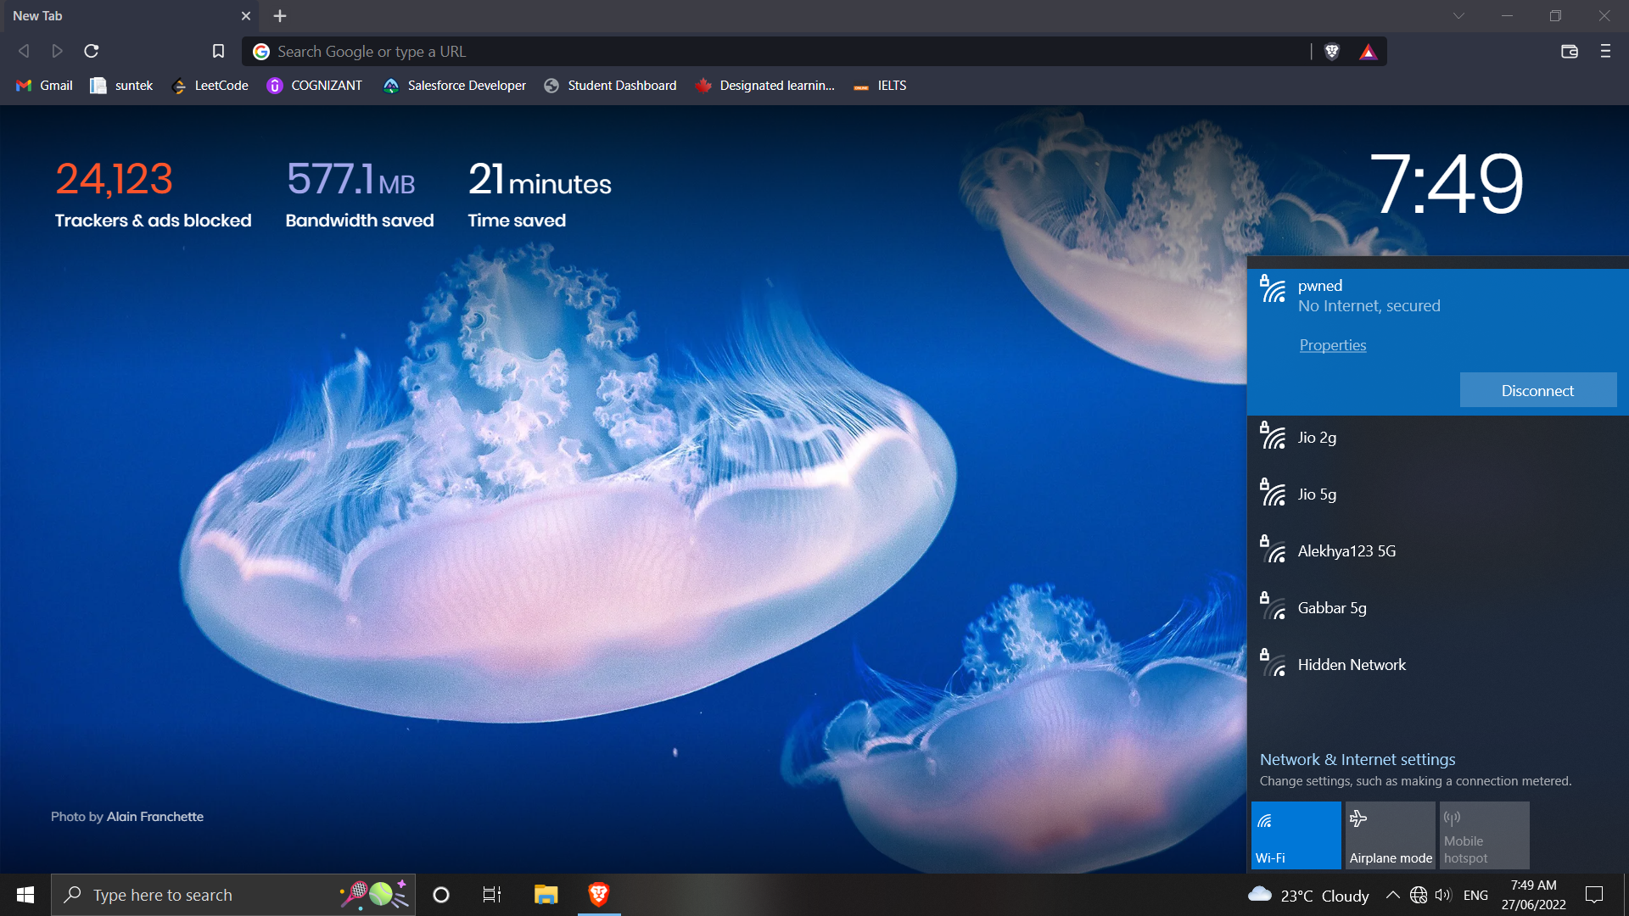



FIG-5.1 CONNECTING TO SSID

**5.2 Scanning Networks**

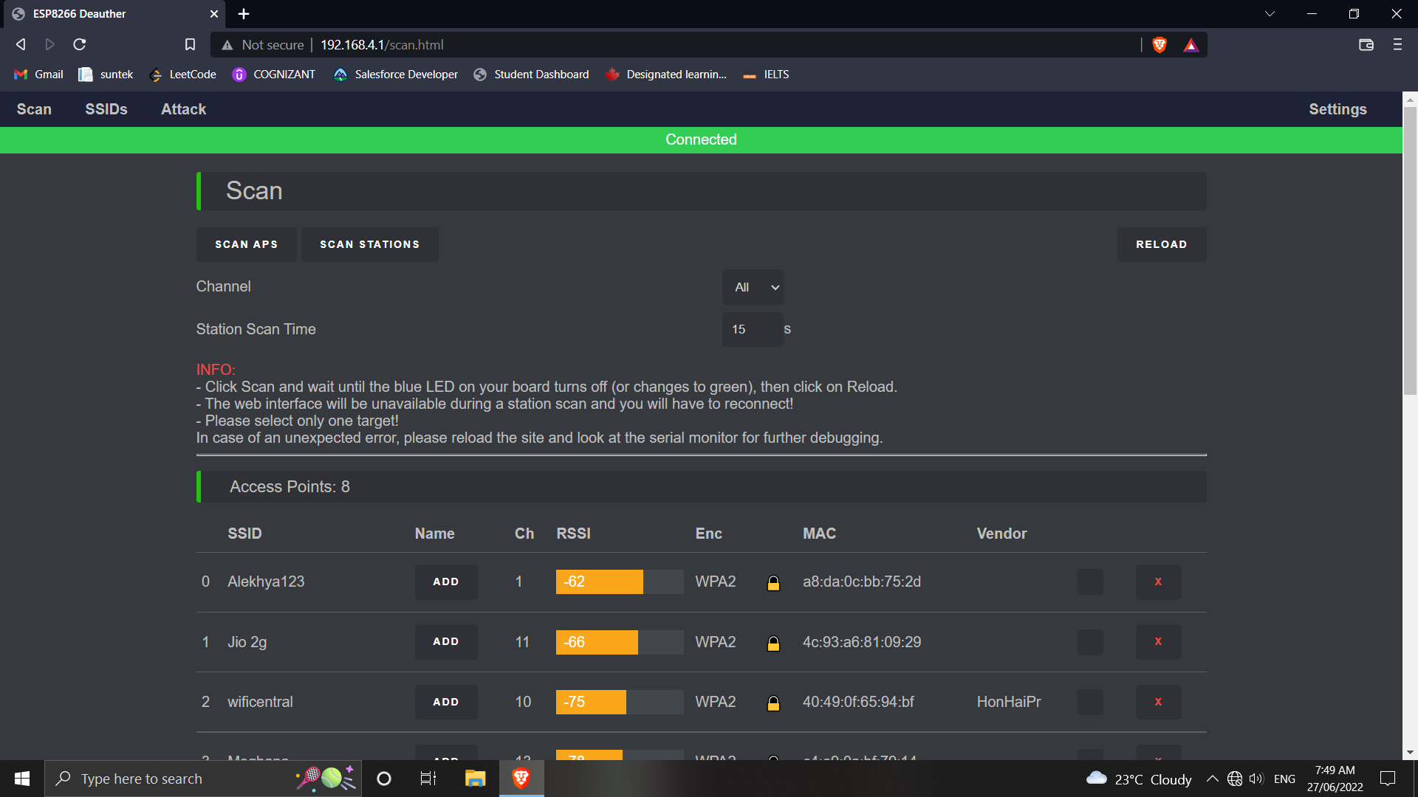

FIG-5.2 SCANNING NETWORKS

**5.3 Selecting Networks**

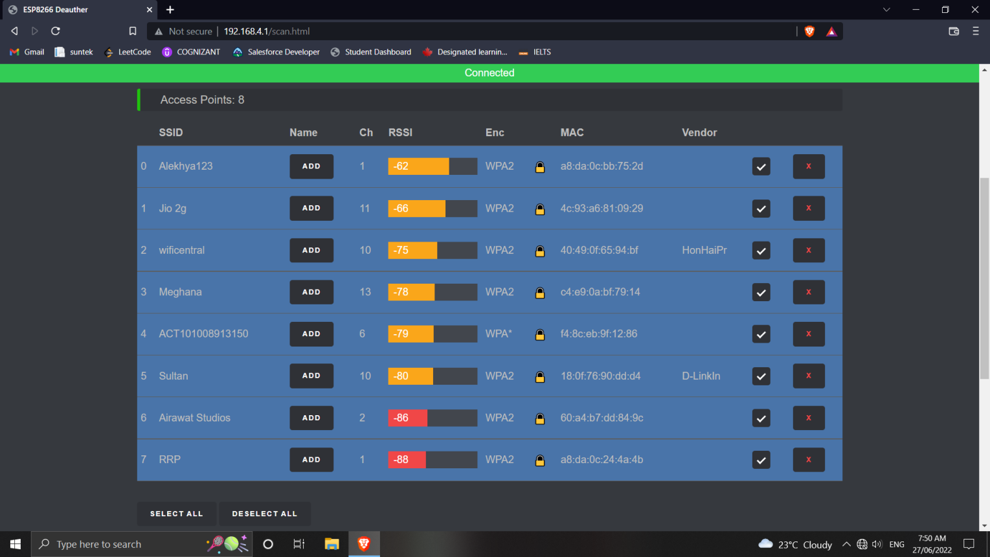

FIG-5.3 SELECTING NETWORKS

**5.4 Selecting Attack**

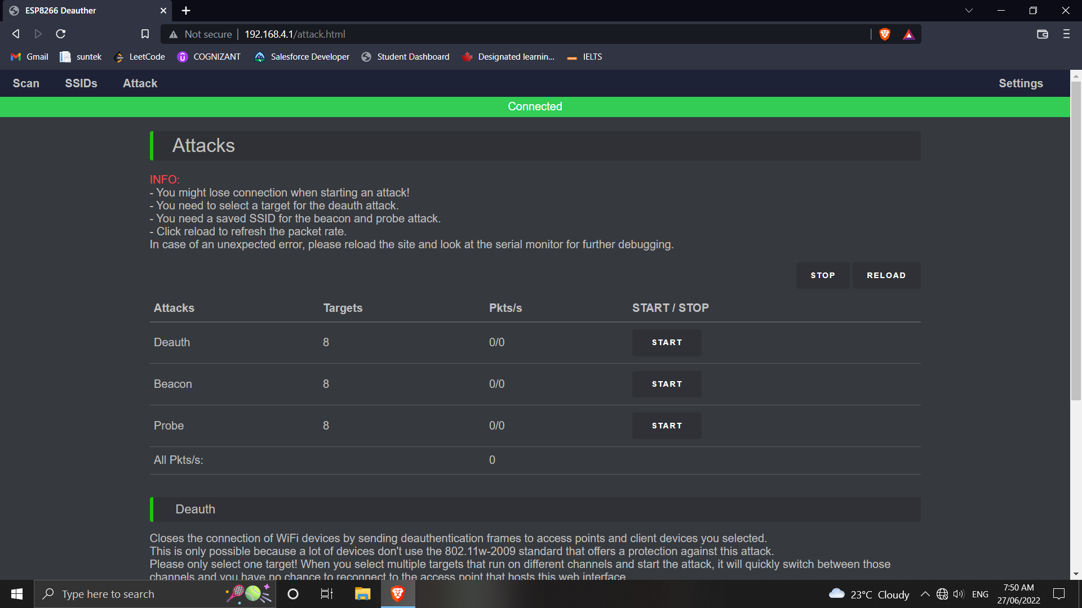

FIG-5.4 SELECTING ATTACK

**5.5 Deauth Attack**

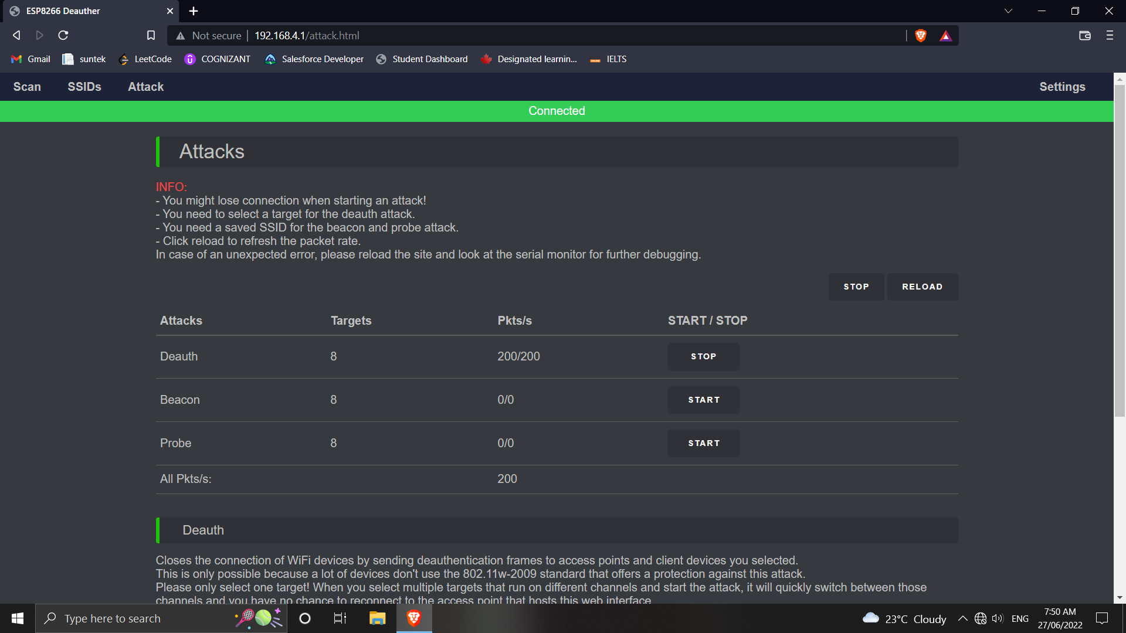

FIG-5.5 Deauth Attack

**5.6 Beacon Attack**

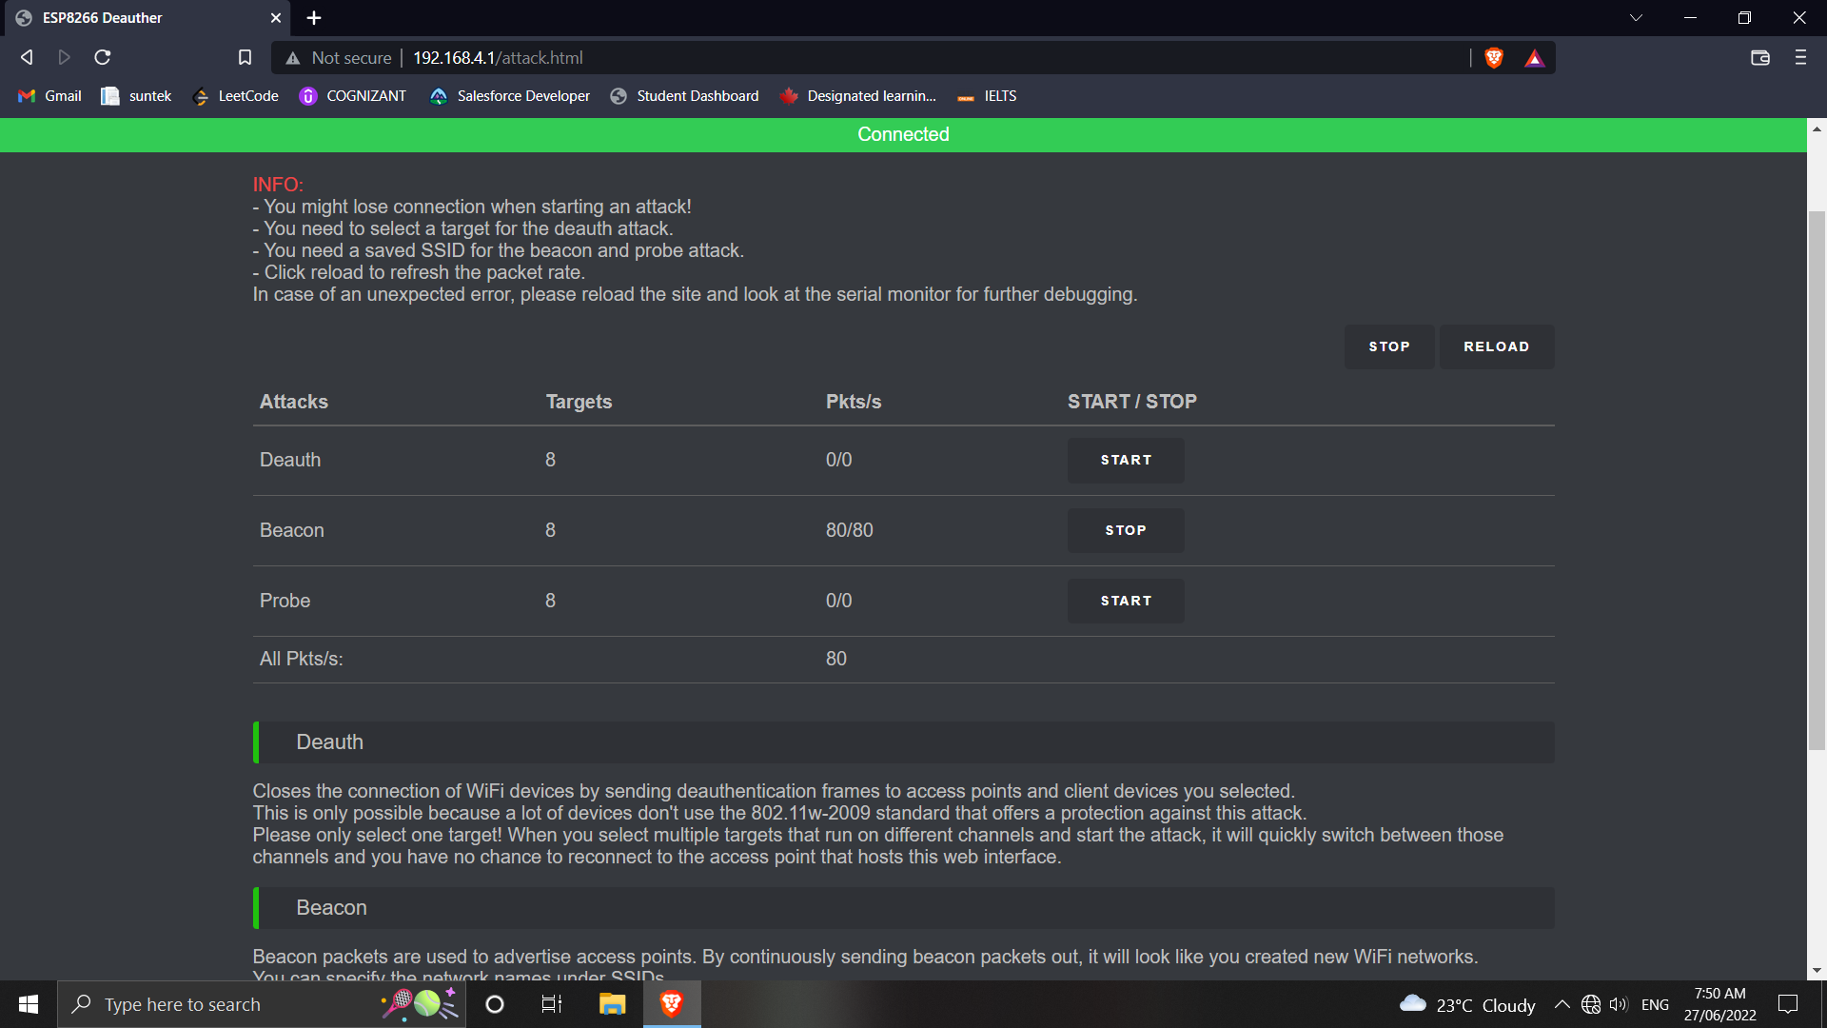

FIG-5.6 BEACON ATTACK

**5.7 Creating Custom SSID’s**

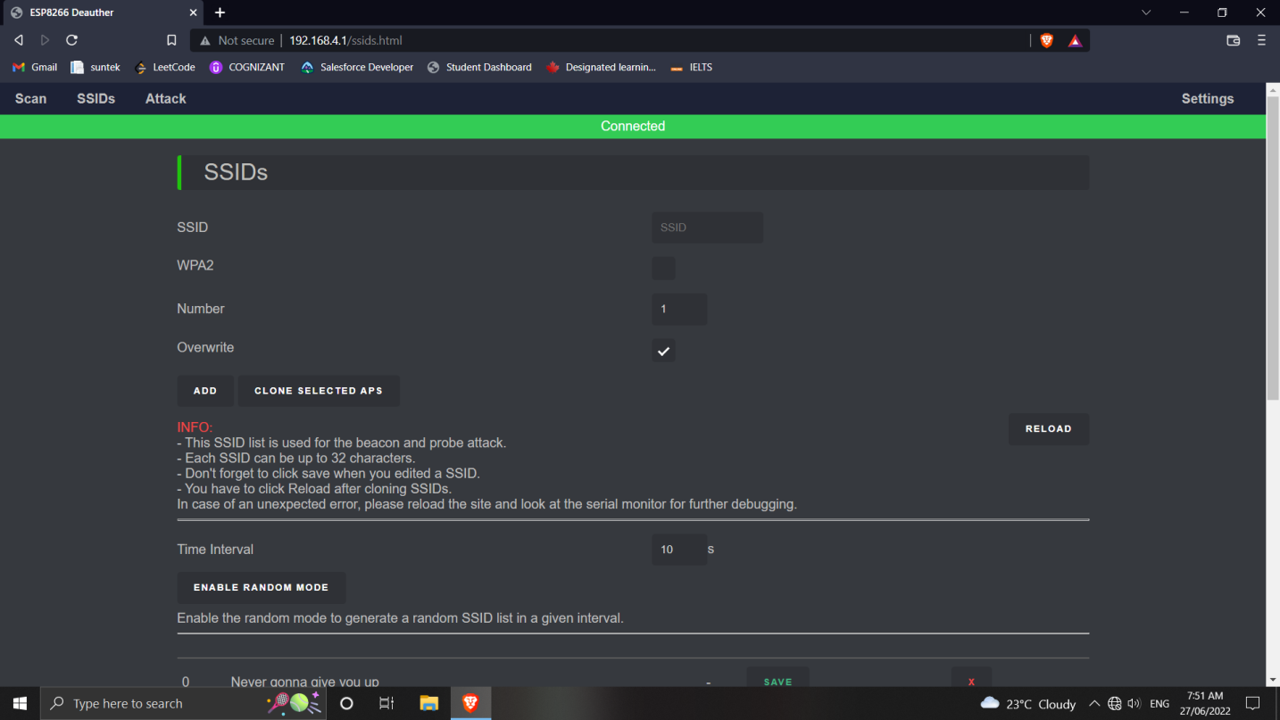

FIG-5.7 CREATNG CUSTOM SSID

**5.8 Enabling Random SSID’s**

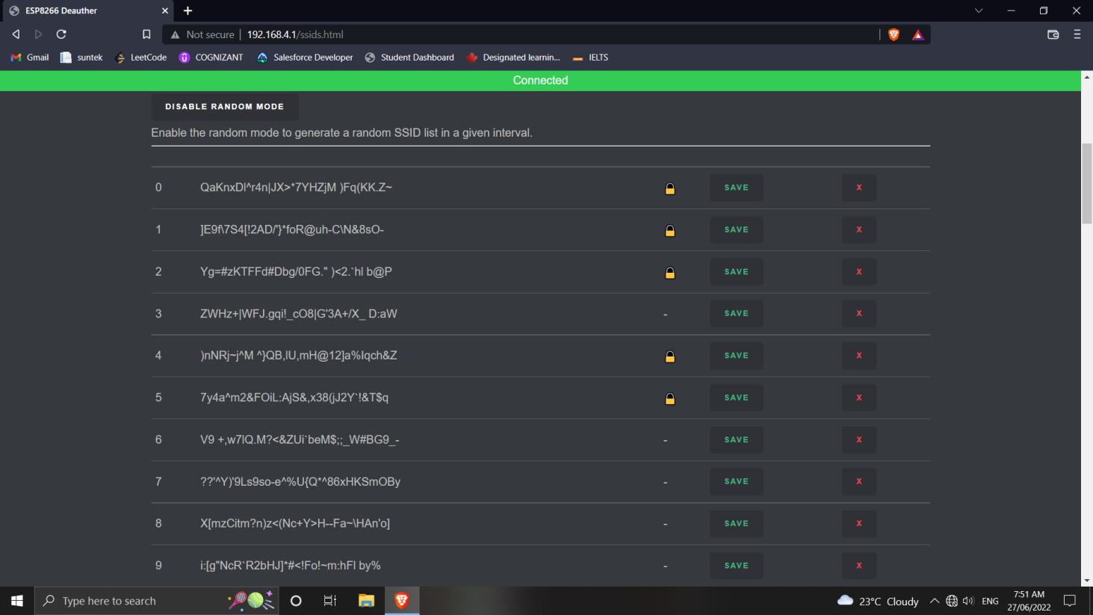

FIG-5.8 ENABLING RANDOM SSID’s

**CHAPTER 6**

**CONCLUSION AND FUTURE ENHANCEMENTS**

**Conclusion :**

Such a powerful tool like the internet needs limitations. It is a great channel for work and pleasure, allowing access to almost anything you can imagine with just a few clicks. On the other hand, it is also a huge risk to your privacy, security, and authority at work and home.

WiFi can be abused, and it often is. Obtaining and using a WiFi Jammer can be the answer to all concerns. Whether we need to regain control of our life, our workplace, or children, blocking WiFi will bring you peace of mind.

It is true that every technology has its advantages and disadvantages regardless of its complexity and perfectness. It is true in case of jamming also. If the technology falls in wrong hands the cost of operation of anti jamming technologies is burden of any government or private telecommunication agencies.

**Future Enhancements :**

* To increase the range of the device from 100 to 200 meters.
* To integrate the system with a mobile application.

**REFERENCES**

* <https://www.researchgate.net/publication/224249602_Analysis_of_Jamming_Effects_on_IEEE_80211_Wireless_Networks>
* <https://www.researchgate.net/publication/221551521_Short_Paper_Reactive_Jamming_in_Wireless_Networks-How_Realistic_is_the_Threat>
* <https://arxiv.org/pdf/2101.00292.pdf>
* <https://www.hindawi.com/journals/scn/2018/7670939/>
* <https://www.ijser.org/researchpaper/Jamming-and-Lost-Link-Detection-in-Wireless-Networks-with-Fuzzy-Logic.pdf>
* <https://www.mdpi.com/1424-8220/21/4/1179/htm>
* <https://kalitut.com/nodemcu-esp8266-wifi-jammer/>
* <https://www.researchgate.net/publication/337656615_Internet_of_Things_and_Nodemcu_A_review_of_use_of_Nodemcu_ESP8266_in_IoT_products>

**APPENDIX**

**Source code:**

extern "C" {

#include "user_interface.h"

}

#include "EEPROMHelper.h"

#include "src/ArduinoJson-v5.13.5/ArduinoJson.h"

#if ARDUINOJSON_VERSION_MAJOR != 5

#error Please upgrade/downgrade ArduinoJSON library to version 5!

#endif // if ARDUINOJSON_VERSION_MAJOR != 5

#include "oui.h"

#include "language.h"

#include "functions.h"

#include "settings.h"

#include "Names.h"

#include "SSIDs.h"

#include "Scan.h"

#include "Attack.h"

#include "CLI.h"

#include "DisplayUI.h"

#include "A_config.h"

#include "led.h"

Names names;

SSIDs ssids;

Accesspoints accesspoints;

Stations stations;

Scan scan;

Attack attack;

CLI cli;

DisplayUI displayUI;

void setup() {

Serial.begin(115200);

Serial.println();

prnt(SETUP_MOUNT_SPIFFS);

LittleFS.begin();

prntln(/*spiffsError ? SETUP_ERROR : */ SETUP_OK);

#ifdef FORMAT_SPIFFS

prnt(SETUP_FORMAT_SPIFFS);

LittleFS.format();

prntln(SETUP_OK);

#endif

#ifdef FORMAT_EEPROM

prnt(SETUP_FORMAT_EEPROM);

EEPROMHelper::format(EEPROM_SIZE);

prntln(SETUP_OK);

#endif

currentTime = millis();

#ifndef RESET_SETTINGS

settings::load();

#else

settings::reset();

settings::save();

#endif

wifi::begin();

wifi_set_promiscuous_rx_cb([](uint8_t* buf, uint16_t len){

scan.sniffer(buf, len);

});

names.load();

ssids.load();

cli.load();

scan.setup(); //

if (settings::getWebSettings().enabled) wifi::startAP();

prntln(SETUP_STARTED);

prntln(DEAUTHER_VERSION);

led::setup();

resetButton = new ButtonPullup(RESET_BUTTON);

}

void loop() {

currentTime = millis();

led::update();

wifi::update();

attack.update();

displayUI.update();

cli.update();

scan.update();

ssids.update();

#ifdef HIGHLIGHT_LED

displayUI.setupLED();

#endif

}

resetButton->update();

if (resetButton->holding(5000)) {

led::setMode(LED_MODE::SCAN);

DISPLAY_MODE _mode = displayUI.mode;

displayUI.mode = DISPLAY_MODE::RESETTING;

displayUI.update(true);

settings::reset();

settings::save(true);delay(2000);

led::setMode(LED_MODE::IDLE);

displayUI.mode = _mode;

}

}